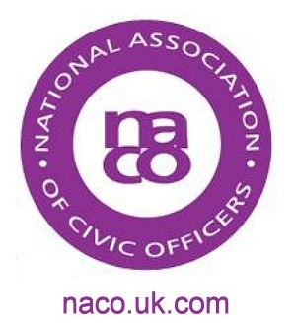
List of dates which may be useful to the Civic Office

2016 | Event | Notes
27 January | Holocaust Memorial Day
28 February | Anniversary of end of Gulf War | 25th anniversary
14 March | WW1 Single Commemorative Act | NACO project – see information on website
14 March | Fly the Flag for Commonwealth Day
17 March | NACO Training Event | Further information on NACO website
21 March | International Day for the Elimination of Racial Discrimination
23 April | St George’s Day | Annual Scout Parades are held near this date
23 April | Celebration of 400 years of Shakespeare’s legacy | William Shakespeare died in 1616
25 April | Anzac Day | Many services are held on the nearest Sunday
8 May | VE Day (marking the end of World War II in Europe)
9 May | Europe Day
12 – 15 May | Pageant celebrating Her Majesty The Queen’s life | Home Park, Windsor Castle
31 May | Centenary of the Battle of Jutland
6 June to 5 July | Ramadan
10 June | National Service of Thanksgiving marking Her Majesty The Queen’s 90th Birthday | St Paul’s Cathedral
11 June | Trooping the Colour | Horse Guards Parade
12 June | Patron’s Lunch celebrating Her Majesty The Queen’s 90th Birthday | The Mall
23 June | Reserves Day | Reserves Day is part of Armed Forces Day programme
25 June | National Armed Forces Day
1 July | Centenary of the Battle of the Somme | Information on events marking this anniversary can be found on www.gov.uk
5 July | Eid
10 July | Disability Awareness Day
30 July | 50th Anniversary of England winning the FIFA World Cup
15 August | VJ Day (marking the end of WWII)
2 September | 350th Anniversary of the Great Fire of London
3 September | Merchant Navy Day
8-11 September | Heritage Open Days | For further information visit heritageopendays.org.uk
1 October | Older Peoples Day
14 October | 950th Anniversary of the Battle of Hastings
21 October | Trafalgar Day
11 November | Armistice Day | 2 minutes silence
13 November | Remembrance Sunday
24 December | 950th Anniversary of William the Conqueror being crowned King of England

