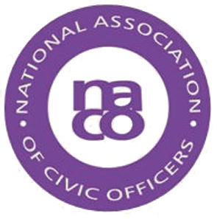

NATIONAL ASSOCIATION OF CIVIC OFFICERS

Notice of Annual General Meeting of NACO to be held Friday 31 March 2017 at 1200 hours Makeney Hall Hotel, near Belper, Derbyshire, DE56 0RS

Nomination Forms for Membership of the Executive of NACO should be emailed to the NACO Secretary, Penny Harrison, on secretary@naco.uk.com by 1800 on Thursday 30 March 2017 or placed in the designated Ballot Box at Makeney Hall Hotel by 1030 on Friday 31 March 2017

