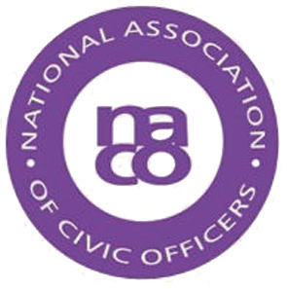

NATIONAL ASSOCIATION OF CIVIC OFFICERS

Notice of Annual General Meeting of NACO to be held Tuesday 6 March 2018 at 1225 hours at the offices of the London Borough of Camden, Judd Street, London, WC1H 9JE

Nomination Forms for Membership of the Executive of NACO should be emailed to the NACO Secretary, Penny Harrison, on secretary@naco.uk.com by 1800 on Monday 5 March 2018 or placed in the designated Ballot Box at Camden Town Hall by 1200 on Tuesday 6 March 2018

.

NATIONAL ASSOCIATION OF CIVIC OFFICERS
naco.uk.com

ANNUAL GENERAL MEETING
to be held at the offices of the London Borough of Camden,
Judd Street, London WC1H 9JE
Tuesday 6 March 2018

AGENDA

1. Apologies

2. Minutes of the AGM 2017

3. Chairman’s Report

4. Secretary’s Report

5. Treasurer’s Report

6. Co-option of Members to the Executive Committee 2017-2018

7. Amendments to Constitution

8. Membership Fee 2018-2019

9. Election of Executive Committee 2018-2019

10. Any Other Business

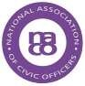

naco.uk.com

NOMINATION FOR MEMBERSHIP OF EXECUTIVE COMMITTEE OF

THE NATIONAL ASSOCIATION OF CIVIC OFFICERS 2018-2019

Nomination Forms should be emailed to the NACO Secretary, Penny Harrison, on secretary@naco.uk.com by 1800 on 5 March 2018 or placed in the designated Ballot Box at the offices of the London Borough of Camden, Judd Street, London, WC21H 9JE by 1200 on 6 March 2018

Nominee:

Position:

Authority:

E
-
mail Address and Telephone Number:

PROPOSER:

E
-
mail Address:

(Proposer must be a member of NACO)

SECONDER:

E-mail Address:

(Seconder must be a member of NACO)

NB:
Should there be less nominations than seats on the Executive Committee it is proposed, with the agreement of the Members present, to elect en bloc. However, in the event that there are more nominations than seats or the AGM wishing to vote for individual candidates, an e-mail/postal ballot will be held following the AGM. Full instructions will be issued to members in the event of an election

