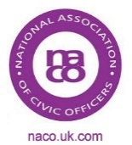
VACANCIES
FOR CIVIC OFFICERS

If anyone wishes to advertise a post on here
please contact secretary@naco.uk.com

Mayor’s Officer
Royal Borough of Windsor & Maidenhead

£9.77 to £11.20 per hour

Permanent Contract, annualised hours up to 1095 per year

DBS Check – Enhanced

Closing Date 19/02/2018 at 23.59 hours

Reference CEM003 - 1802

For full details visit
https://ats-rbwm.jobsgopublic.com/vacancies/view/53730

PA to Chairman and Vice Chairman
Braintree District Council

Full Time, 37 Hours Per Week
Salary £27,951 to £30,459 per annum

Closing Date 28/02/2018

For full details visit
https://www.braintree.gov.uk/directory_record/6859/pa_to_the_chairman_and_corporate_management_board

