**Tea Parties to celebrate**

**Older Age, Community and a 70th Birthday**

**Some Questions and Answers**

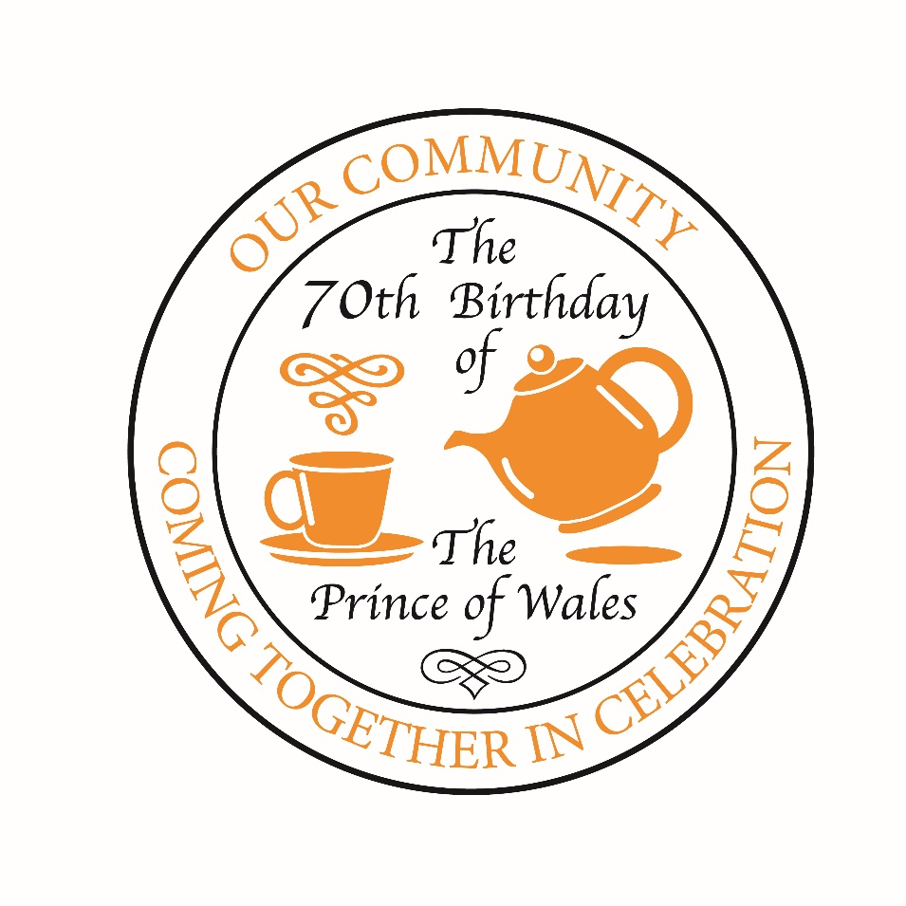

**What’s this all about?**

The Prince of Wales will be 70 on Wednesday 14th November this year, and events will be taking place across the country from 14th to 17th November to mark the occasion.

NACO’s hope is that the many organisations which are cornerstones of our communities will come together to organise tea parties for local people who are 70 or who are in their 70s.

The purpose is simple:

* It is about celebrating all that those in their 70s have contributed and continue to contribute to our communities
* It is about celebrating all those things that are positive and good and which we all share within our communities
* In the period between Remembrance and the lead up to Christmas it is a chance to brighten an autumn afternoon with a birthday tea party sometime between Wednesday 14th and Saturday 17th November as part of this nationwide initiative
* It is a chance to join with The Prince of Wales in celebrating his own milestone birthday.

**Who can organise an event?**

Anyone! Some National Trust properties are organising teas. (The Prince of Wales is President of the Trust). Many Age UK groups are taking part. (The Prince of Wales is their Royal Patron). Parishes across the country already hold teas for older people and many are making those occasions a special birthday tea and inviting new faces along to join them

**What do we have to do?**

The good thing is, you really don’t have to do a lot. Of course, if you can afford to really push the boat out (and not many can nowadays) you might host a tea party for seventy 70-year-olds.

Perhaps it is more realistic to ask a local shop or supermarket to donate a couple of cakes and invite seven 70-year-olds in for tea with your Lord Mayor, Mayor or Chair.

You just need to make sure it is a safe, professionally run event which creates time for individuals to meet and enjoy time together.

**When are the Teas taking place?**

The Prince of Wales celebrates his birthday on Wednesday 14th November, so ideally events should take place any time between 14th and 17th November, but if you can only arrange something later in the month, don’t let that stop you. It is the coming together that’s important.

**Is it just for older people?**

Given the time available, you may not have chance to involve many others, but if The Prince’s Trust is active in your community you could make it an intergenerational event by involving their volunteers.  And if not The Prince’s Trust, then maybe local Cadets, Scouts or Guides could take part.

**Is there a logo?**

Of course! Feel free to use it for any event you are organising: Tea Party, Birthday Lunch, Birthday Coffee morning or any other community celebration. Just lift the image at the top of this page or contact [**vicechair@naco.uk.com**](mailto:vicechair@naco.uk.com)

**And if we are not organising a Tea ourselves?**

Just ask around. There is every chance that your local Age U.K. branch or nearby National Trust property will be thinking about organising something. Churches, Mosques, Synagogues or Temples in your area may have plans. Are there Care Homes and Older People’s Centres in your area that your Lord Mayor, Mayor or Chair visits from time to time?  Why not ask if they are organising a birthday tea? If it is a community event they have in mind, then they may well want to invite your Lord Mayor, Mayor or Chair to visit, to reinforce that sense of a community coming together.

**Who else should we be involving?**

Your Authority may well have a Councillor who is appointed Older People’s Champion.  Why not involve them in getting word out that this is a reason for a great community event?  And with a little imagination it might not have cost implications for the Council.

Civic Officers are often the people with the best contacts’ lists in the whole Council.  This is a chance to use your contacts to join different parts of your community.

**What else should we be doing?**

Please, do remember to:

* Tell NACO about events you are organising or involved with (email [**vicechair@naco.uk.com**](mailto:vicechair@naco.uk.com)) so we can build up a picture of what is happening and where;
* Arrange for photographs to come to NACO ([**vicechair@naco.uk.com**](mailto:vicechair@naco.uk.com)) so that we can put together a gallery showing how, across the UK, we found ways to celebrate The Prince of Wales’s birthday whilst helping to strengthen communities and link generations.

**If I have any further questions…….?**

Please contact: [vicechair@naco.uk.com](mailto:vicechair@naco.uk.com)

***And remember ……………………***

The Duchess of Cornwall is on record as saying that “technology now offers so many ways to communicate, but sitting down for a chat over a cup of tea can still be counted as one of the most enjoyable”.  Very many of us would share that sentiment and a 70th Birthday Tea seems a great opportunity to do just that.