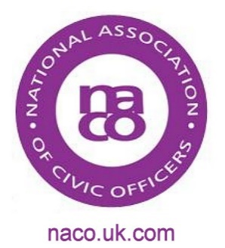
List of 2017 dates which may be useful to the Civic Office
Designated days for Union Flag Flying – detailed guidance on this can be found on the Government’s website at https://www.gov.uk/guidance/designated-days-for-union-flag-flying

2017 | Event | Notes
27 January | Holocaust Memorial Day
28 January | Chinese New Year | 2017 is the Year of the Rooster
3 March | 170th anniversary of the Birth of Alexander Graham Bell
8 March | International Women’s Day
13 March | WW1 Single Commemorative Act | NACO project – see information on website
13 March | Fly the Flag for Commonwealth Day
21 March | International Day for the Elimination of Racial Discrimination
30 and 31 March | NACO Training Event | Further information on NACO website
23 April | St George’s Day | Annual Scout Parades are held near this date
25 April | Anzac Day | Many services are held on the nearest Sunday
8 May | VE Day (marking the end of World War II in Europe)
9 May | Europe Day
6 June to 5 July | Ramadan
11 June | Trooping the Colour | Horse Guards Parade
23 June | Reserves Day | Reserves Day is part of Armed Forces Day programme
24 June | National Armed Forces Day
5 July | Eid
10 July | Disability Awareness Day
July | 100th anniversary of the House of Windsor
15 August | VJ Day (marking the end of WWII)
31 August | 20th Anniversary of the death of Diana, Princess of Wales
3 September | Merchant Navy Day
8-11 September | Heritage Open Days | For further information visit heritageopendays.org.uk
1 October | Older Peoples Day
21 October | Trafalgar Day
30 October | Festival of Devali
11 November | Armistice Day | 2 minutes silence
12 November | Remembrance Sunday
20 November | Platinum Wedding Anniversary of The Queen and Prince Philip
29 November | Centenary of the founding of the Womens Royal Naval Service (WRENS)

