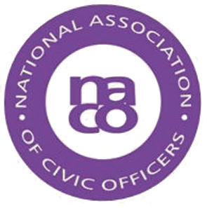

NACO will be holding its Annual General Meeting on Friday 31 March 2017 during the Training Event taking place in Makeney Hall, Belper.

The formal Notice and Agenda for the meeting, along with the minutes from the last AGM, are below but before you read these do take a moment to consider if you feel you could become more involved and be a member of the Executive Committee. We are a friendly bunch doing our best to help civic staff throughout the country. We welcome new faces who can support the Association, particularly in these very difficult times for Local Authority staff.

If you feel you would like to be a member of the Executive a Nomination Form is also attached. If you would like more information about the Executive please contact the Secretary, Penny Harrison, on secretary@naco.uk.com

February 2017

NATIONAL ASSOCIATION OF CIVIC OFFICERS

Notice of Annual General Meeting of NACO to be held Friday 31 March 2017 at 1200 hours Makeney Hall Hotel, near Belper, Derbyshire, DE56 0RS

Nomination Forms for Membership of the Executive of NACO should be emailed to the NACO Secretary, Penny Harrison, on secretary@naco.uk.com by 1800 on Thursday 30 March 2017 or placed in the designated Ballot Box at Makeney Hall Hotel by 1030 on Friday 31 March 2017

.

NATIONAL ASSOCIATION OF CIVIC OFFICERS

ANNUAL GENERAL MEETING
to be held Makeney Hall, Belper, DE56 0RS
Friday 31 March 2017

AGENDA
naco.uk.com

- Apologies

- Minutes of the AGM 2016

- Chairman’s Report

- Secretary’s Report

- Treasurer’s Report

- Co-option of Members to the Executive Committee 2016-2017

- Amendments to Constitution

- Membership Fee 2017-2018

- Election of Executive Committee 2017-2018

- Any Other Business

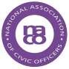

naco.uk.com

NOMINATION FOR MEMBERSHIP OF EXECUTIVE COMMITTEE OF THE NATIONAL ASSOCIATION OF CIVIC OFFICERS 2017-2018

Nomination Forms should be emailed to the NACO Secretary, Penny Harrison, on secretary@naco.uk.com by 1800 on 30 March 2017 or placed in the designated Ballot Box at Makeney Hall Hotel, Belper, DE56 0RS by 1030 on 31 March 2017

NOMINEE:

Position:

Authority:

E
-
mail Address and Telephone Number:

PROPOSER:

E
-
mail Address:

(Proposer must be a member of NACO)

SECONDER:

E-mail Address:

(Seconder must be a member of NACO)

NB:
Should there be less nominations than seats on the Executive Committee it is proposed, with the agreement of the Members present, to elect en bloc. However, in the event that there are more nominations than seats or the AGM wishing to vote for individual candidates, an e-mail/postal ballot will be held following the AGM. Full instructions will be issued to members in the event of an election.

